🧩 Common Types of Proxies
# Source: AI Source: Provided by: [Data Path: Persons Table -> ID Column: 1, Name_En Column: Motasem Essam] -> From: [ChatGPT] on [1/16/2026]
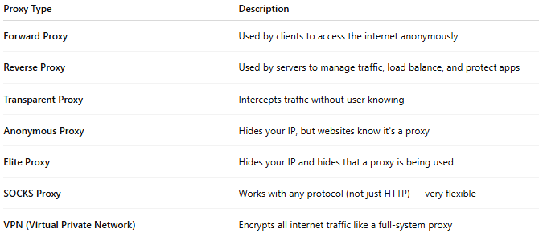
Proxy Type | Description
Forward Proxy | Used by clients to access the internet anonymously
Reverse Proxy | Used by servers to manage traffic, load balance, and protect apps
Transparent Proxy | Intercepts traffic without user knowing
Anonymous Proxy | Hides your IP, but websites know it's a proxy
Elite Proxy | Hides your IP and hides that a proxy is being used
SOCKS Proxy | Works with any protocol (not just HTTP) — very flexible
VPN (Virtual Private Network) | Encrypts all internet traffic like a full-system proxy

